Maven Project

Step 1 :

Create a maven Project

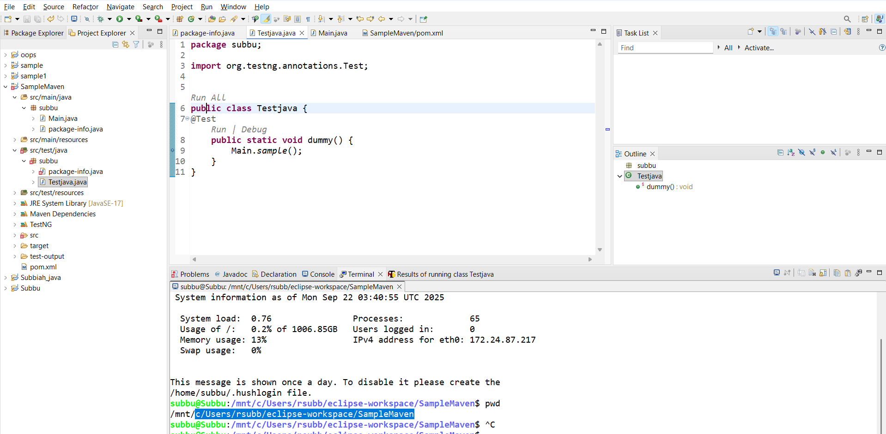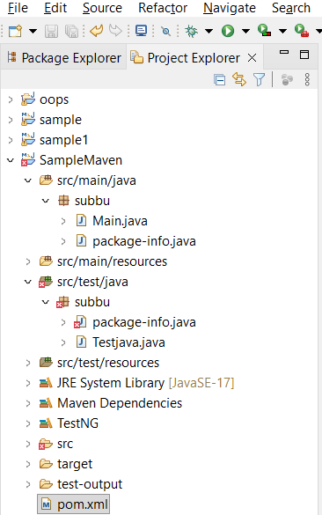

Step 2:

Push the maven Project into GitHub

GitHub Link: <https://github.com/subbiahramu/MavenProject>

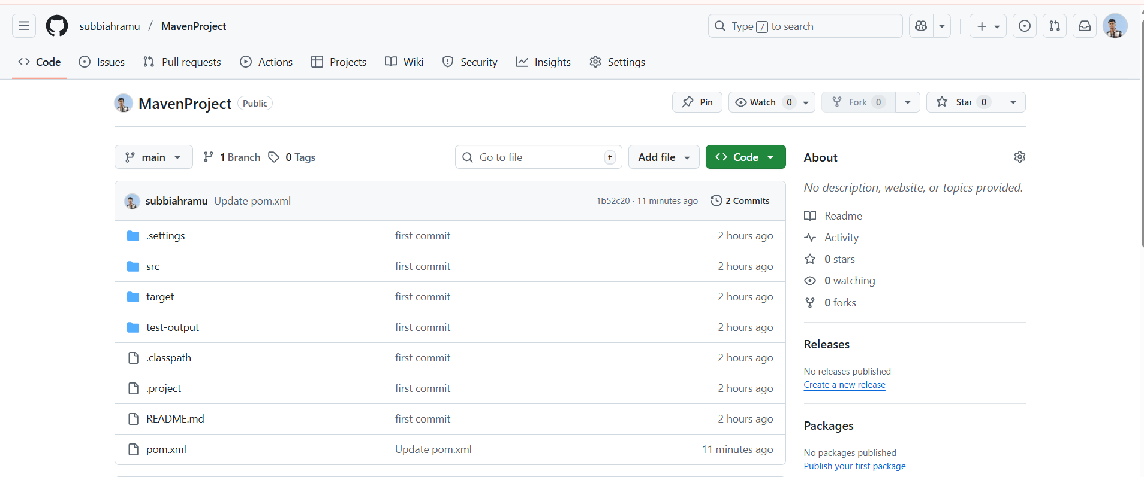

Step 3:  
Test the Maven Using Jenkins

Jenkins Pipeline script:

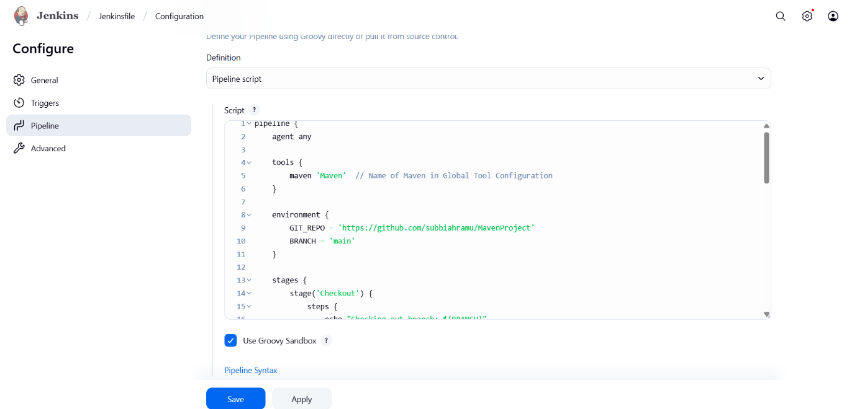

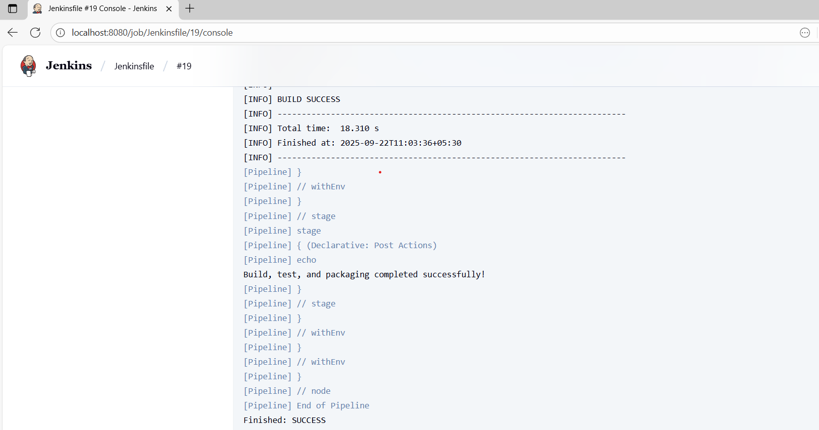

Step 4:  
Track the Process using JIRA

